Test Case: tc003_SPX_Dev5_Crear_Requisicion_Spot_Tipo_Cobro_CC_Urgent
Step 1 - Enter username and password and click to button Enter : Credentials Entered
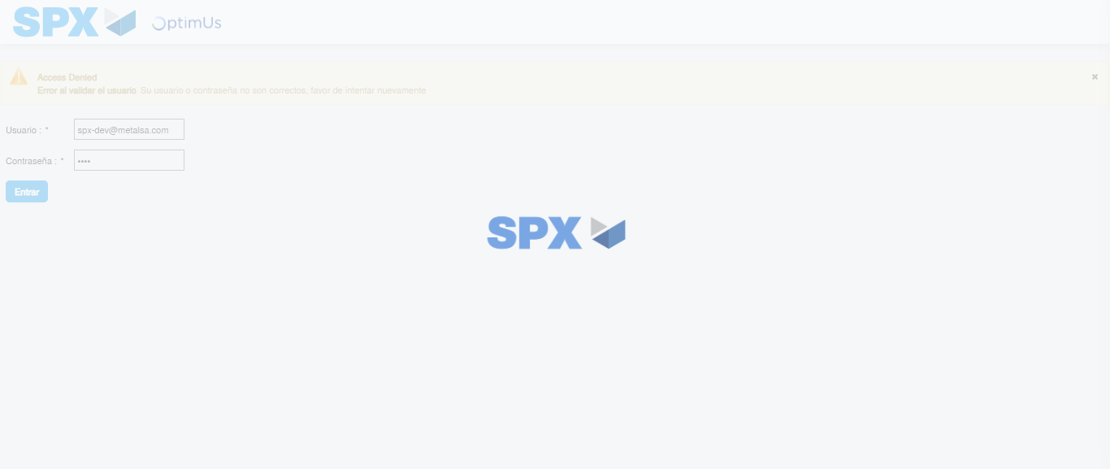Image file-name: QC_Testing-tc003_SPX_Dev5_Crear_Requisicion_Spot_Tipo_Cobro_CC_Urgent-1785960304854

Step 2 - Select to UEN and Access to Spot Buy Requisitions : UEN Correctly selected and Correct access
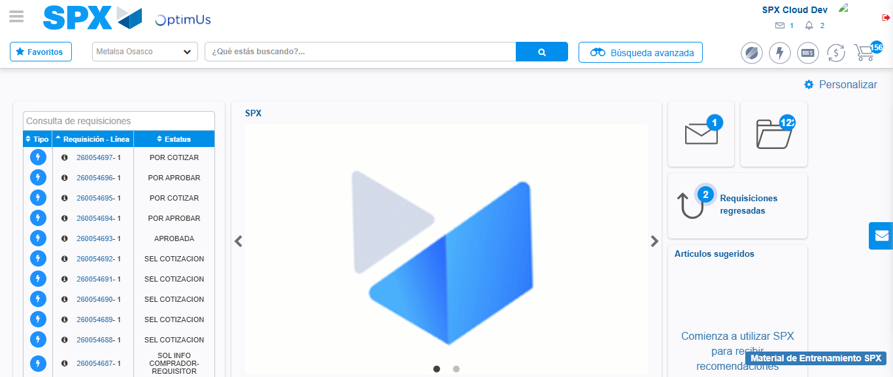Image file-name: QC_Testing-tc003_SPX_Dev5_Crear_Requisicion_Spot_Tipo_Cobro_CC_Urgent-1785960331646

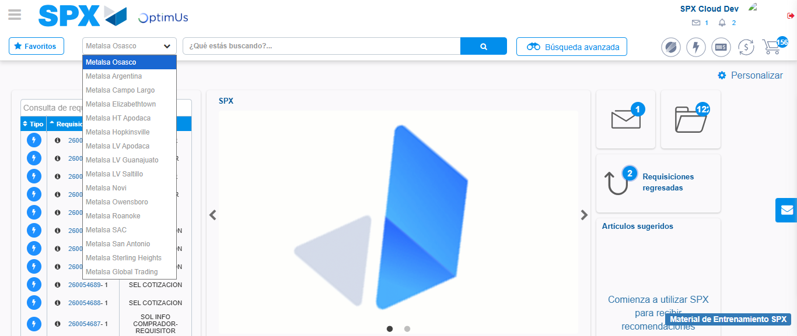Image file-name: QC_Testing-tc003_SPX_Dev5_Crear_Requisicion_Spot_Tipo_Cobro_CC_Urgent-1785960334587

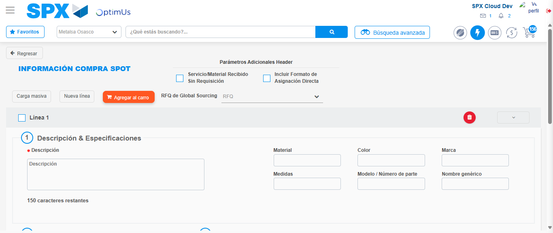Image file-name: QC_Testing-tc003_SPX_Dev5_Crear_Requisicion_Spot_Tipo_Cobro_CC_Urgent-1785960342410

Step 3 - Data Capture Spot Buy Requisition: Data captured correctly
Image file-name: QC_Testing-tc003_SPX_Dev5_Crear_Requisicion_Spot_Tipo_Cobro_CC_Urgent-1785960342685

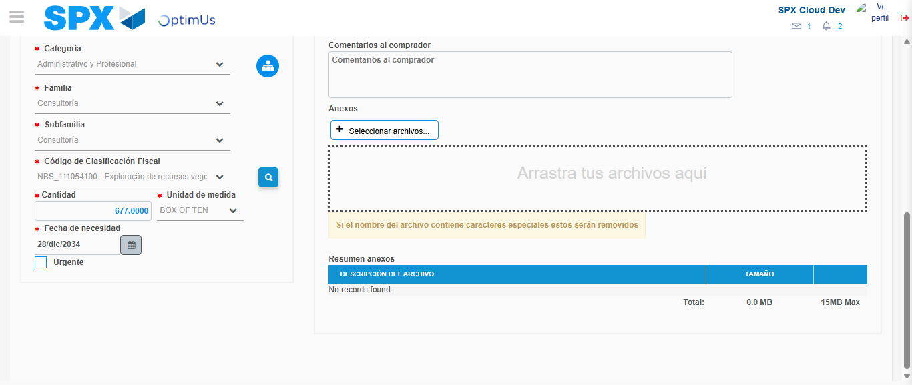Image file-name: QC_Testing-tc003_SPX_Dev5_Crear_Requisicion_Spot_Tipo_Cobro_CC_Urgent-1785960360395

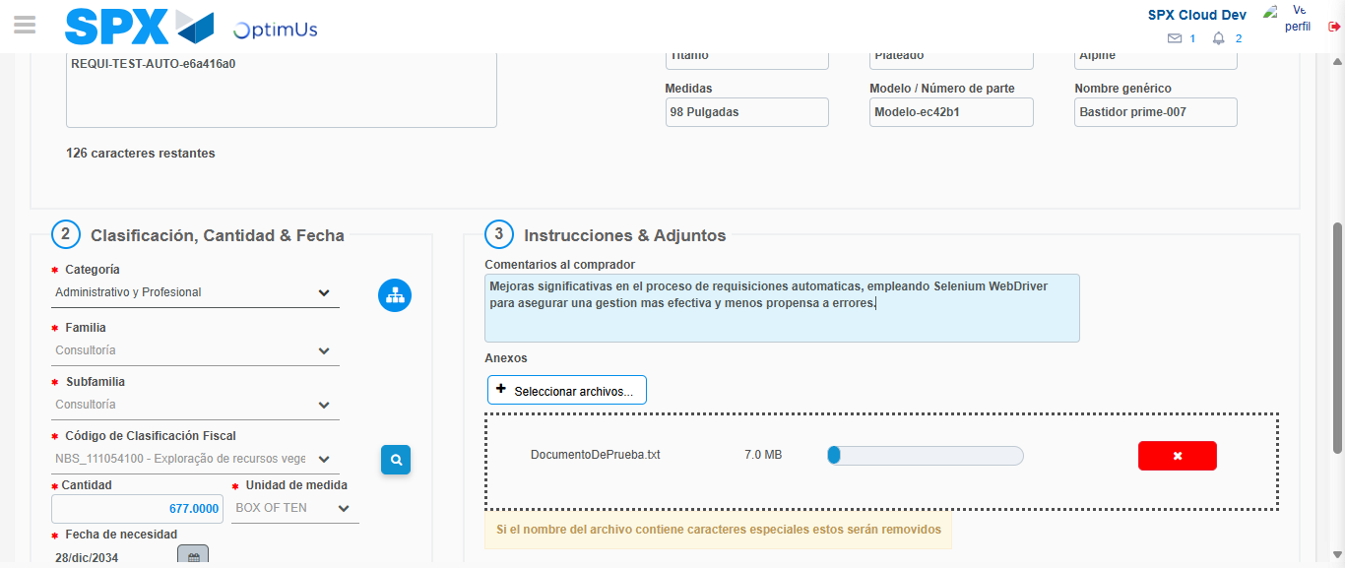Image file-name: QC_Testing-tc003_SPX_Dev5_Crear_Requisicion_Spot_Tipo_Cobro_CC_Urgent-1785960361283

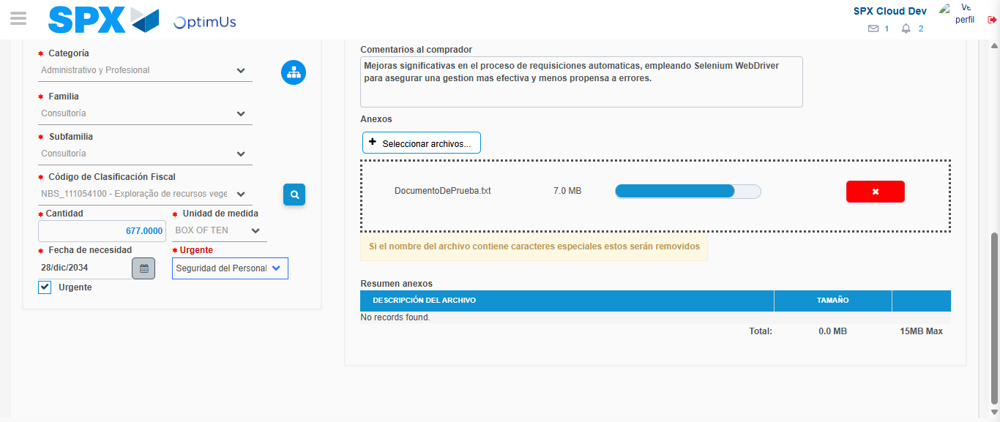Image file-name: QC_Testing-tc003_SPX_Dev5_Crear_Requisicion_Spot_Tipo_Cobro_CC_Urgent-1785960365005

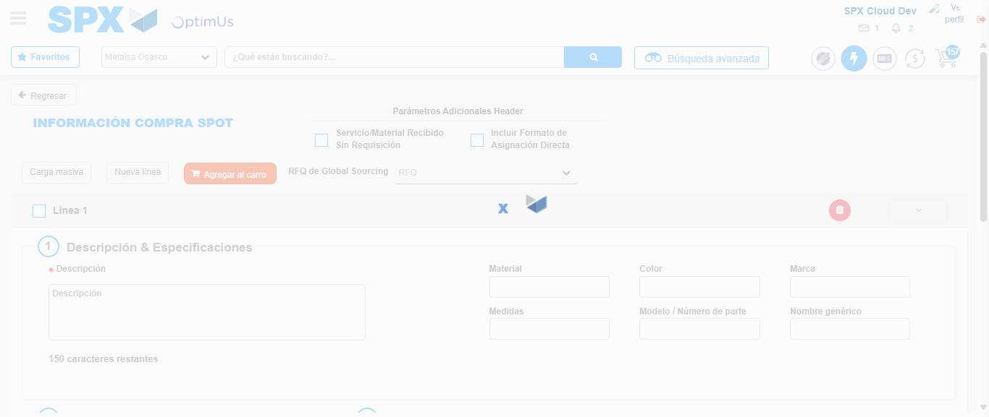Image file-name: QC_Testing-tc003_SPX_Dev5_Crear_Requisicion_Spot_Tipo_Cobro_CC_Urgent-1785960372006

Step 7 - Return to Main Page SPX : Return to Main Page SPX
Image file-name: QC_Testing-tc003_SPX_Dev5_Crear_Requisicion_Spot_Tipo_Cobro_CC_Urgent-1785960331646

Image file-name: QC_Testing-tc003_SPX_Dev5_Crear_Requisicion_Spot_Tipo_Cobro_CC_Urgent-1785960334587

Image file-name: QC_Testing-tc003_SPX_Dev5_Crear_Requisicion_Spot_Tipo_Cobro_CC_Urgent-1785960342410

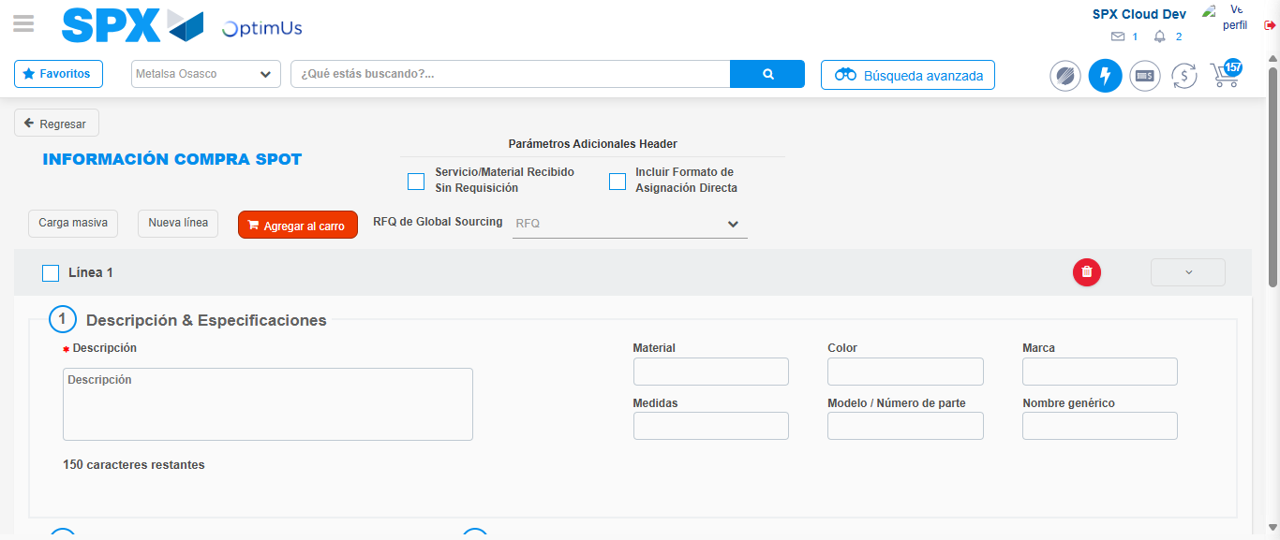Image file-name: QC_Testing-tc003_SPX_Dev5_Crear_Requisicion_Spot_Tipo_Cobro_CC_Urgent-1785960374243

Image file-name: QC_Testing-tc003_SPX_Dev5_Crear_Requisicion_Spot_Tipo_Cobro_CC_Urgent-1785960374434

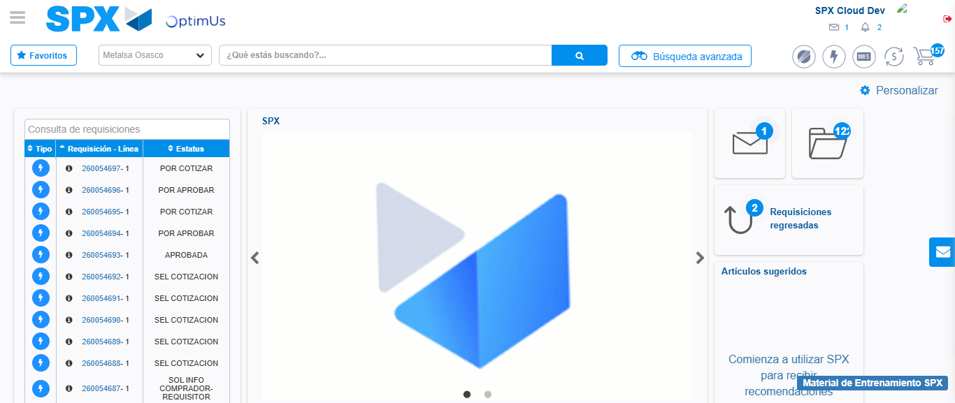Image file-name: QC_Testing-tc003_SPX_Dev5_Crear_Requisicion_Spot_Tipo_Cobro_CC_Urgent-1785960395513

Step 8 - Log Out : Log Out SPX
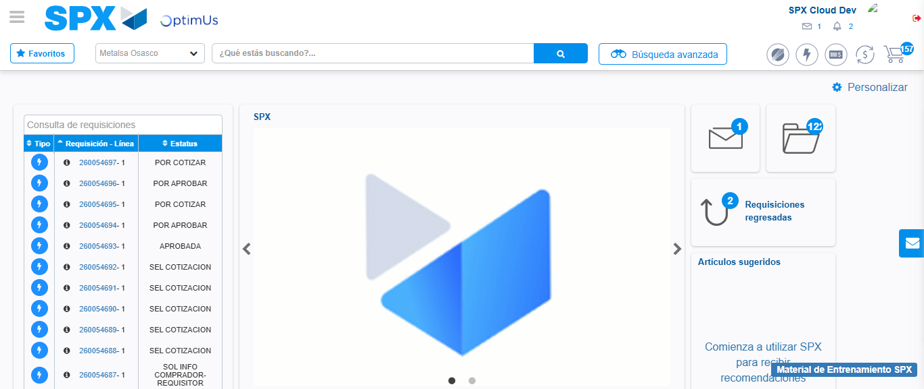Image file-name: QC_Testing-tc003_SPX_Dev5_Crear_Requisicion_Spot_Tipo_Cobro_CC_Urgent-1785960395819

